*Report for the subject*

**HUMANITIES FOR ENGINEERS**

**(UHU005)**

*titled*

**Impacts of Taliban’s Takeover**

**on Afghanistan**

**Prepared by:**

Aryan Shanker Saxena 102103613

Devansh Agarwal 102103620

Dhruv Gupta 102103622

**Submitted to:**

Dr. Razia



THAPAR INSTITUTE OF ENGINEERING & TECHNOLOGY, PATIALA

Nov 8, 2024

**CERTIFICATE**

This is to certify that the Report titled - Impacts of Taliban’s Takeover on Afghanistan- embodies the original work done by Aryan Shanker Saxena, Devansh Agarwal and Dhruv Gupta in fulfilment of the project work given by the School of Humanities and Social Sciences, Thapar Institute of Engineering and Technology during the year 2024.

Nov 8, 2024

Dr. Razia

Thapar Institute of Engineering & Technology

Patiala

**LETTER OF TRANSMITTAL**

Devansh Agarwal

B.E., Computer Engineering

Thapar Institute of Engineering & Technology

Nov 8, 2024

Ms. Nazia

School of Humanities and Social Sciences

Thapar Institute of Engineering & Technology

Subject: Report on Impacts of Taliban’s Takeover on Afghanistan

Respected Ma’am,

With due respect, we would like to submit our report entitled “Impacts of Taliban’s Takeover on Afghanistan” which discusses the current effects of this takeover on the general public and economy, and also the future impacts the country could face.

We hope for the best actions that could be taken for the benefit of the country.

Yours sincerely,

Devansh Agarwal

B.E. Computer Engineering Student

Thapar Institute of Engineering & Technology

**ACKNOWLEDGEMENT**

In the accomplishment of this project successfully, many people have bestowed upon us their blessings and the heart pledged support, this time we are utilizing to thank all the people who have been concerned with this project. We would like to express our special thanks to our teacher Dr. Razia who gave us the golden opportunity to do this wonderful project on the topic ‘Impacts of Taliban’s Takeover on Afghanistan’. We would like to express our gratitude towards our parents & our fellow mates for their kind cooperation and encouragement which helped us in completion of the project.

**INDEX**

|  |  |  |
| --- | --- | --- |
|  |  |  |
|  | *Certificate* | *i* |
|  | *Letter of Transmittal* | *ii* |
|  | *Acknowledgement* | *iii* |
|  | *Abstract* | *v* |
|  | *List of Illustrations* | *vi* |
|  | *Copyright Notice* | *vii* |
| 1 | Introduction  1.1 Background  1.2 Objectives  1.3 Authorisation  1.4 Research Methodology  1.5 General Structure | 1  1  2  3  3  3 |
| 2 | Discussion  2.1 Effect on the General Public  2.2 Abolition of Women’s and Girl’s Rights  2.3 Effects on Economy  2.3.1 Inflation  2.3.2 Ban on Opium Production  2.3.3 Job Insecurity  2.4 Breach of media freedom, speech and assembly | 4  4  5  6  6  8  9  10 |
| 3 | Conclusions | 12 |
| 4 | Recommendations | 14 |
|  | References | 15 |
|  | Appendix | 16 |

**ABSTRACT**

The Taliban takeover of Afghanistan accelerated the country’s human rights crisis and humanitarian catastrophe. After the Taliban took control of the country on August 15, 2021, they rolled back women’s rights advances and media freedom – the foremost achievements of the post-2001 reconstruction effort. Many secondary schools for girls remained closed by the end of the year, and women were largely prohibited from working in jobs outside of teaching and health care. The chaotic evacuation of thousands of Afghans left behind many who remained at risk of Taliban retaliation. Taliban forces executed many former members of the Afghan government’s security forces. A freeze on Afghanistan’s currency reserves and the loss of foreign aid accelerated an economic collapse, leaving millions of Afghans at risk of famine. The collapse of the country’s health services meant that many Afghans faced a loss of most physical and mental health care. This report focuses about the major challenges faced by Afghanistan (dire economic conditions, compromised media freedom and violation of human rights) after Taliban’s takeover and provides a set of key policy recommendations for UN concerned with stability and prosperity for all Afghans.

**LIST OF ILLUSTRATIONS**

|  |  |  |
| --- | --- | --- |
|  |  |  |
| Fig 2.1 | Afghanistan’s currency vs U.S. Dollars | 6 |
| Fig 2.2 | Afghanistan conflict casualties, 2021 | 7 |
| Fig 2.3 | Afghanistan Unemployment rate | 8 |

**COPYRIGHT NOTICE**

©Copyright 2024 by Thapar Institute of Engineering and Technology. All rights reserved. This material may not be duplicated for any profit driven approach.

The reports contained in these Internet-accessible directories are included by the contributing authors as a mechanism to ensure the timely dissemination of scholarly and technical information on a non-commercial basis. Copyright and all rights therein are maintained by the authors, despite their having offered this information electronically. Everyone copying this information must adhere to the terms and constraints invoked by each author's copyright.

Reports may not be copied for commercial redistribution, republication, or dissemination without the explicit permission of the School of Humanities & Social Sciences at Thapar Institute of Engineering & Technology, Patiala and the authors.

**CHAPTER - 1**

**Introduction**

**1.1 Background**

Following al- Qaeda’s September 11, 2001 strikes, the US invaded Afghanistan after the Taliban administration refused to hand up terrorist leader Osama bin Laden. The Taliban leadership swiftly lost control of the country and fled to southern Afghanistan, just over the Pakistani border. They launched an uprising against the Western-backed Kabul government, Afghan national security forces, and international coalition troops from there.

The ANDSF was put in charge of Afghanistan’s security when the US-led coalition formally finished its combat operation in 2014. The ANDSF*, however, struggled to maintain land and defend population centres, while the Taliban continued to target rural regions and carry out suicide attacks in major towns. For nearly six years, the conflict was basically a stalemate.

The US administration and the Taliban signed a peace agreement in February 2020, after more than a year of direct negotiations, that established a schedule for the departure of US troops from Afghanistan. Under the terms of the agreement, the US promised to reduce its troop strength to around 8,500 within 135 days and execute a full pull-out within 14 months. In exchange, the Taliban agreed to prevent terrorist groups from using areas under their control and to engage in talks with the Afghan government. However, no formal cease-fire was implemented. The Taliban promptly resumed attacks on Afghan security forces and civilians after a brief lull in hostilities. The Afghan government and the Taliban initiated direct discussions months after the agreed-upon start date.

In 2020 and 2021, violence in Afghanistan rose as the US launched air strikes and operations against the Taliban. Meanwhile, the Taliban launched attacks against Afghan government and security forces, gaining territory.

Over the last few years, civilian casualties in Afghanistan have remained high. In 2018, the United Nations recorded a then-record number of 10,993 civilian deaths. Despite a minor decrease in 2019, civilian casualties surpassed 10,000 for the sixth year in a row,

bringing the total UN-documented civilian casualties to more than 100,000 since 2009. Despite another drop in 2020, the Taliban increased their military onslaught in the first half of 2021, resulting in a record number of civilian deaths as international soldiers withdrew.

The Afghan economy has been pressured by the uncertainty surrounding the future of international support. Although the US and its partners promised to continue supporting the Afghan government in late 2020, aid could be reduced following the Taliban’s takeover. A move like this might exacerbate Afghanistan’s already dire economic position.

**1.2 Objectives**

The primary objective of this report is to comprehensively analyze the multi-dimensional impact of the Taliban's resurgence in Afghanistan following their takeover in August 2021. The report aims to shed light on the socio-political and economic upheavals faced by the general public, with a focus on vulnerable communities such as women, children, and minority groups. The report also examines the adverse effects on governance and human rights, particularly through the lens of women's and girls' rights, as well as the economic ramifications marked by inflation and financial instability.

The objectives of this report are as follows:

1. **To assess the impact on the general public**: This includes examining the surge in violence, civilian casualties, targeted killings, and forced evictions perpetrated by both the Taliban and ISKP forces. The report seeks to highlight the suffering of Afghanistan’s most vulnerable communities, such as the Hazara Shia population.
2. **To evaluate the erosion of women’s and girls’ rights**: This section aims to identify the significant restrictions imposed on women’s employment, education, and freedom of movement, exploring how these policies reflect a reversal of progress made in previous years.
3. **To understand the economic effects**: The objective is to analyze how the Taliban’s return to power has destabilized Afghanistan’s economy, leading to hyperinflation, soaring prices of basic goods, and declining purchasing power of citizens. This includes investigating the impact on essential services and humanitarian aid.
4. **To synthesize findings for future policy considerations**: By presenting a detailed overview of the social, political, and economic crises post-Taliban takeover, this report aims to inform policymakers, humanitarian organizations, and international bodies for potential action plans that could support the Afghan population during this time of crisis.

These objectives serve as the foundational structure of the report, ensuring that the content provides an in-depth examination of the issues while aiming to contribute to a more comprehensive understanding of the impact on Afghanistan and its people.

**1.3 Authorisation**

We have been assigned the authority by Dr. Razia to write this report.

**1.4 Research Methodology**

For the detailed analysis of Afghanistan’s economic position and state of human rights after Taliban’s takeover we have used secondary data which include interviews, local news and online articles from reliable sources. This has been presented in the form of graphs to clarify the role Taliban has played on Afghanistan’s economy and people.

The data has been collected majorly from credible websites and reports based on the incident.

**1.5 General Structure**

This report consists of four chapters i.e. Introduction, discussion, conclusion and recommendations. The first chapter gives a background of the events that led to the takeover of Afghanistan by the Taliban. The second chapter discusses the effects it had on the country which include the violation of women’s rights, effect on the general public, economy and job security. It also describes how it hampered media freedom, speech and assembly.

These have been supported by some pictorial representations including graphs depicting inflation, job insecurity and some important future indicators. The third chapter lists the conclusions that we tend to derive from this report based on which the recommendations have been listed in the fourth and last chapter.

**CHAPTER - 2**

**Discussion**

**2.1 Effect on the General Public**

Taliban forces were responsible for approximately 40% of civilian deaths and injuries in the first six months of 2021, despite the fact that many cases went unreported. Nearly half of all civilian deaths were women and children. Assassinations and a handful of deadly explosions were among the ISKP's* attacks.

Many attacks targeted Afghanistan’s Hazara Shia community. On May 8, three explosions at the Sayed al-Shuhada school in Kabul killed at least 85 civilians, including 42 girls and 28 women, and injured over 200—the vast majority from the Hazara community. The attack was unclaimed but occurred in a predominantly Hazara neighbourhood that ISKP had repeatedly targeted. On October 8, a suicide bombing during Friday prayer at a Shia Mosque in Kunduz killed at least 72 people and injured over 140; the ISKP claimed responsibility. On March 4, gunmen fatally shot seven Hazara laborers at a plastics factory in Jalalabad.

At least dozens of former officials and security force employees were killed in retaliation by Taliban fighters in numerous districts. The Taliban killed at least 19 security force employees in their hands, as well as a number of civilians, after seizing control of Malistan, Ghazni, in mid-July. After the Taliban conquered Spin Boldak in July, at least 44 former security force members were slain by advancing Taliban troops in Kandahar. The Taliban had taken them all. Other provinces, as well as Kabul, had reliable allegations of detentions and killings.

Civilians, including government personnel, journalists, and religious leaders, were targeted by both the Taliban and the ISKP. Unidentified gunmen killed two women justices working for Afghanistan's supreme court and wounded their driver on January 17, 2021. Between March and June, the ISKP claimed responsibility for the deaths of nine polio vaccine workers in Nangarhar. ISKP claimed responsibility for the killings of ten humanitarian deminers in Baghlan on June 9. An ISKP suicide bomber killed 170 civilians at Kabul's airport in August, including many Afghans attempting to exit the country.

Taliban forces also violently evicted civilians from their houses in a number of provinces, including Daykundi, Uruzgan, Kunduz, and Kandahar, in revenge for the locals' alleged support for the previous administration. Hundreds of Hazara families from the Gizab district of Uruzgan province and nearby districts of Daykundi province were forced to abandon their homes and flee in September, in the greatest of these expulsions. In indiscriminate mortar and rocket attacks, both the Taliban and Afghan government security forces killed and injured people, while civilian casualties from previous government forces' airstrikes more than doubled in the first half of 2021 compared to the same period in 2020.

According to witnesses, as the Taliban advanced into Kabul, a strike force unit from the former government's National Directorate of Security kidnapped and executed 12 recently released former inmates. On August 29, the US launched a drone strike on a car allegedly carrying explosives on its way to Kabul's airport. The car was really driven by an NGO employee who was supposed to be evacuated to the United States. The US Defense Department stated two weeks later that the strike was a "tragic blunder" that killed ten civilians, including seven children.

**2.2 Abolition of Women’s and Girl’s Rights**

Taliban officials published a regular stream of laws and regulations restricting women's and girls' rights in the weeks following their takeover. These included restrictions on employment and education, as well as restrictions on the right to peaceful assembly. The Taliban also targeted high-profile women, denying them the right to leave their homes.

Although the Taliban have stated that they encourage female education, on September 18 they ordered secondary schools to reopen only for boys. In a few provinces, some secondary schools for girls reopened, although the vast majority remained closed as of October. On August 29, the interim minister of higher education said that girls and women would be able to attend university but would not be able to study with boys and men. Due to a shortage of female teachers, particularly in higher education, many girls and women will undoubtedly be denied access to education as a result of this policy.

In certain regions, women who had taught boys in levels above sixth grade or men in mixed classes at university have been fired because teaching males is no longer permitted. Taliban officials have prohibited or restricted female humanitarian workers in several places of Afghanistan, potentially jeopardising access to health care and humanitarian aid. Almost all female government officials have also been fired by the Taliban. Women's return to work was "postponed" until the Taliban's Ministry of Rural Development created a "system for how they will work," the Taliban's Ministry of Rural Development said in September. When women were allowed to return to work, they were subjected to workplace gender segregation restrictions.

The Taliban abolished the Ministry of Women's Affairs in September and repurposed its building as the Ministry for the Propagation of Virtue and Prevention of Vice, an institution tasked with enforcing rules on citizens' behaviour, such as how women dress and when or whether they can leave the house without a male relative. Shelters for women fleeing domestic violence are closed, and some of the women who stayed there have been transferred to women's prisons.

**2.3 Effects on Economy**

**2.3.1 Inflation**

The Afghan economy has been in a state of crisis since the Taliban took control of the country in August 2021. One of the most pressing issues has been the rapid acceleration of inflation, which is severely impacting the purchasing power of ordinary Afghans.

Prices for many basic consumer goods have risen dramatically over the past year. Market surveys in Kabul have found that the cost of a 50kg bag of flour has increased by around 30%, from 1,700 afghanis to 2,200 afghanis. Similar spikes have been seen for other staple foods like cooking oil, rice, and vegetables - with prices for these items rising by up to 50%.

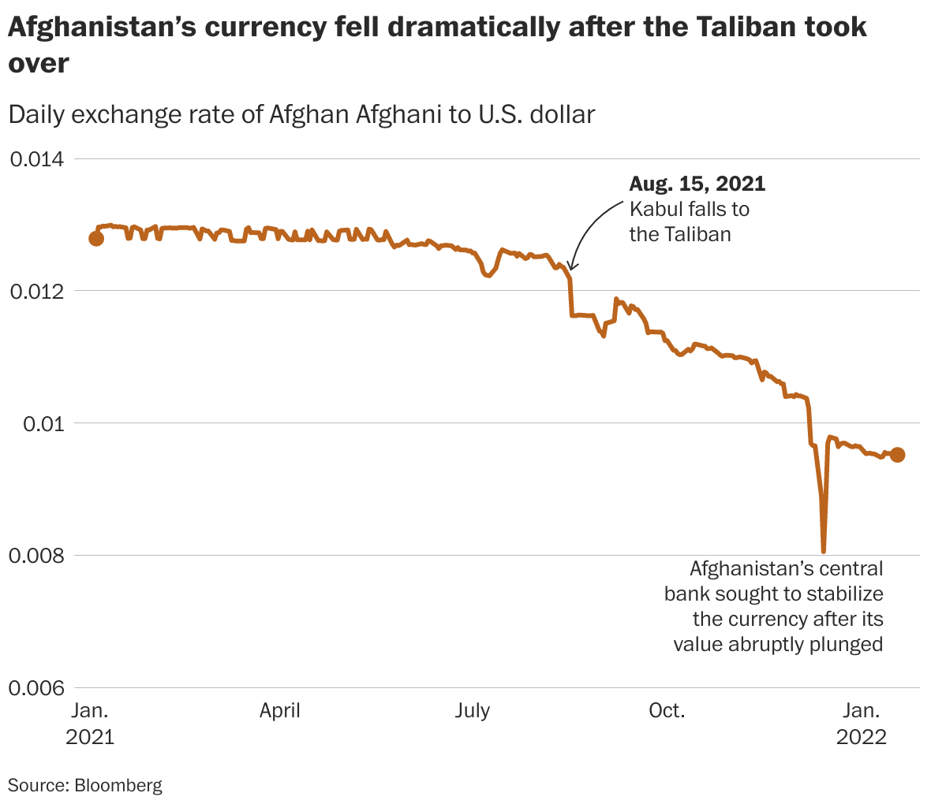

Fig 2.1 Afghanistan’s currency vs U.S. Dollars

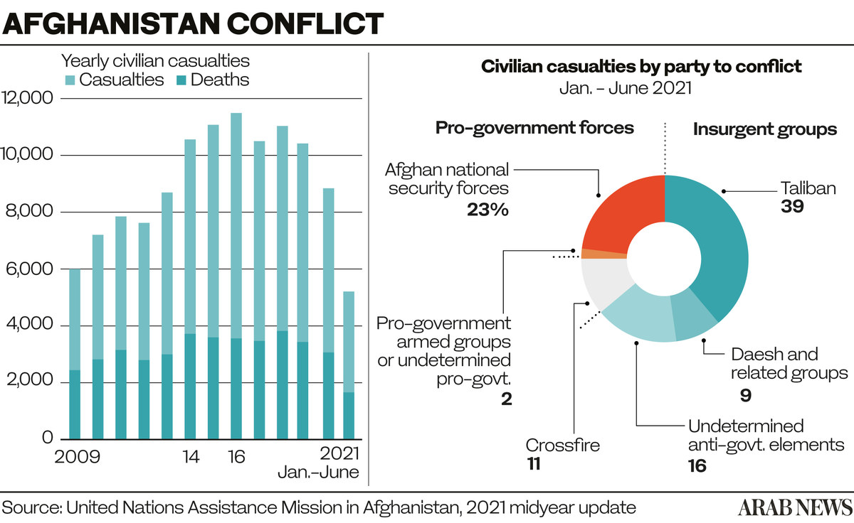

Fig 2.2 Afghanistan conflict casualties, 2021

The cost of gasoline has also soared, increasing by as much as 75% compared to pre-Taliban levels. This has driven up transportation costs, further exacerbating the inflationary pressures faced by Afghan consumers.

A major driver of this runaway inflation has been the collapsing value of the Afghan currency, the afghani, against the US dollar. Since August 2021, the afghani has lost around 40% of its value, plummeting from 80 afghanis per dollar to over 100 afghanis per dollar currently. This has made imports much more expensive, with the costs then passed on to consumers.

The closure of money transfer services like Western Union has also contributed to the economic turmoil. These services had provided a vital lifeline for many Afghan families in the form of remittances from overseas, but their suspension has cut off this source of income and foreign exchange.

With incomes disappearing due to job losses and unpaid salaries, Afghans are struggling to afford even basic necessities. Many are resorting to selling jewelry, household goods, and other assets just to make ends meet - often having to accept a fraction of their true value.

The combination of galloping inflation, plummeting currency value, and dwindling incomes has created a perfect storm of economic hardship for the Afghan people. Urgent action and international support will be needed to stabilize the situation and provide relief.

**2.3.2 Ban on Opium Production**

Afghanistan has long been the world's leading producer of opium, the raw ingredient for heroin. Prior to the Taliban's return to power in 2021, the country generated over 6,000 metric tons of opium annually, accounting for more than 80% of global opium supply.

The opium trade has been a crucial part of Afghanistan's economy for decades, providing livelihoods and income for millions of impoverished farmers. According to UN estimates, the opium industry was worth between $1.8 - $2.7 billion in 2021, equivalent to over 7% of Afghanistan's GDP.

Despite efforts by the US and international community to eradicate opium cultivation - spending over $8 billion on counter-narcotics programs - production has remained stubbornly high. The profits and ingrained role of opium in rural economies have proven extremely difficult to disrupt.

However, soon after regaining control of Afghanistan, the Taliban issued a decree banning all opium production. The directive states: "If anyone violates the decree, the crop will be destroyed immediately and the violator will be treated according to the Sharia law." The sale of heroin, hashish, and alcohol has also been made illegal under the Taliban's interpretation of Islamic law.

This crackdown on the opium trade represents a major shift in policy from the previous Taliban regime in the 1990s, when the group taxed and profited from the drug trade. The current Taliban leadership has portrayed the ban as an ideological and moral stance against the "intoxicants" that are damaging Afghan society.

Yet the economic ramifications could be severe. Opium farming is a crucial source of income for impoverished rural communities, and the loss of this revenue stream will exacerbate the country's acute economic crisis. With jobs scarce and the banking system crippled, many Afghans may have few alternatives to cultivating the lucrative opium crop.

There are also concerns that the opium ban could trigger civil unrest, as farmers and traffickers resist losing their livelihoods. Some experts warn that it could even precipitate a resurgence of the Taliban's own reliance on the opium trade to fund their insurgency, should the economic pressures become too great.

Overall, the Taliban's move to eradicate Afghanistan's opium industry represents a significant gamble. While ideologically aligned with their hardline Islamist ideology, it also risks further destabilizing the country's already fragile economy and social fabric.

**2.3.3 Job Insecurity**

The Taliban's return to power in Afghanistan in August 2021 has had a devastating impact on employment and job security across the country. The withdrawal of US and international forces, coupled with the collapse of the previous Afghan government, has plunged the country into a severe economic crisis.

Many public sector workers, including crucial healthcare personnel, have not been paid for months as government budgets have dried up. This has left hospitals and clinics severely understaffed and unable to provide adequate services to the Afghan people.

Beyond the public sector, private businesses and industries have also been hit hard by the economic turmoil. Investors and companies have fled the country, leading to widespread business closures and mass layoffs. Afghanistan's banking system has also largely ground to a halt, further constraining economic activity and cutting off salaries.

With jobs scarce and incomes disappearing, many Afghans are struggling to meet their basic needs. Families that previously relied on a regular pay check are now forced to resort to selling off assets like jewellery and household goods just to survive. The closure of money transfer services like Western Union has also cut off a vital lifeline of remittances from relatives overseas.

This severe employment and livelihood crisis is wreaking havoc on Afghan society. Malnutrition and food insecurity are on the rise, as families can no longer afford sufficient food. The health system, already fragile, is on the verge of collapse as medical personnel go unpaid. And the risk of social unrest and even civil conflict is mounting as more Afghans fall into destitution.

Compounding the problem, the Taliban's hardline Islamist ideology and restrictions on women's rights have further limited employment opportunities, especially for female workers. This is devastating for a country where women have historically played a crucial role in the workforce, particularly in the public sector.

Without urgent international intervention and economic support, the job security crisis in Afghanistan looks set to worsen. Restoring employment, government salaries, and a functional banking system will be essential to alleviating the country's spiralling humanitarian emergency. The stakes for the Afghan people could not be higher.

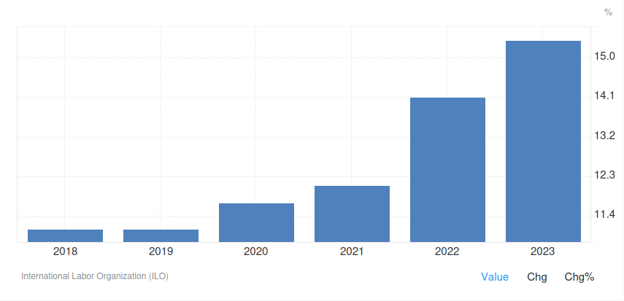

Fig 2.3 Afghanistan Unemployment rate

**2.4 Breach of media freedom, speech and assembly**

Nearly 70% of Afghan media outlets closed once the Taliban took control, while others were threatened and self-censored. The Taliban imposed broad limitations on the media and free speech in September, including prohibitions on "insulting national figures" and reporting that could have a "negative impact on public opinion." Two journalists from the Etilaat-e Roz media organisation were detained by Taliban security forces on September 7 and severely beaten in captivity before being released. The journalists had been reporting women's protests in Kabul. After seizing power in Kabul, the Taliban imprisoned at least 32 journalists.

On July 6, the former Afghan government declared that broadcasting news "against the national interest" was illegal. After returning from Spin Boldak, Kandahar, where they had been investigating the Taliban's capture of the district, four journalists were arrested by the former government's intelligence service on July 26. They were not released until August 13, when Kandahar fell to the Taliban.

Afghan women staged protests in numerous locations beginning September 2 to oppose Taliban practices that violate women's rights. Taliban fighters in Herat slashed demonstrators and shot weapons at random to disperse the gathering, killing two individuals and wounding at least eight more. Protests that did not receive prior authorisation from the Justice Ministry in Kabul were later outlawed by the Taliban. Despite this, some protests continued.

**CHAPTER - 3**

**Conclusions**

With the sudden Taliban takeover in August, Afghanistan now faces severe, multi-faceted, and interlocking humanitarian, economic, and political crises. The evacuation of thousands of Afghans, some of whom are highly skilled and educated, has impacted the institutional functioning of Afghanistan’s public sector. Taking the above scenario into consideration, enduring peace in Afghanistan is not only seeking to eliminate violence, but also to bring positive interaction between state and society. As the country stands on the precipice of a major catastrophe, there is one global actor that can help the country pull back from the brink: the United Nations.

Prior to and during Afghanistan’s nearly four-decades of continuous wars—and in particular when the country was all but forgotten by the international community during the Taliban’s previous period of rule—the UN remained engaged. It is vital that the organization continues its life-saving support to Afghanistan today. Founded in 1945 in the wake of World War II, the United Nations is, first and foremost, a conflict management organization with a tested peace-making, humanitarian response, and development assistance toolkit. During the post-cold war era, the UN has demonstrated the ability—even in the most difficult circumstances—to forge a common approach among major and regional powers in pursuing peace and safeguarding the most vulnerable within a war-shattered society. Precisely by providing a continual forum and field presence, the world body can create favourable conditions for peaceful dispute settlement, while also discouraging and inhibiting unilateral foreign interference that often inflames a conflict.

With some persuasion along the way by the United Nations, whose influence draws heavily from regional and Security Council support, it is conceivable that the Taliban can be persuaded to work with a new, educated generation of Afghans—before yet more depart—on a new course that steers away from violent brutality, exploitative corruption, and widespread deprivation. To navigate the severe, multi-faceted, and interlocking humanitarian, economic, and political crises Afghanistan now faces, the United Nations is well-placed to offer critical life-saving assistance and to help Afghans avert another major catastrophe. With the backing of major global and regional powers and the cooperation of both Taliban and non-Taliban factions alike, the UN can help to place Afghanistan on a new political path for a more stable country that, over time, improves the prospects for all Afghan citizens.

**CHAPTER - 4**

**Recommendations**

Emergency appeals have been launched by international assistance organisations in anticipation of increasing workload. While Afghanistan's HRP# is underfunded and in need of further help, Afghan-led organisations will be carrying a heavier role in the short term. The UN should commit to raising money for Afghan-led groups immediately, and collaborate with partners in Europe, the Gulf, and abroad to fully fund the humanitarian response. To achieve this degree of engagement, bureaucratic will is required to overcome structural barriers that prevent direct sponsorship of local organisations. This can be accomplished through pooled finance or other established methods that secure the safety and operational continuity of community-led organisations while also providing for spending monitoring and responsibility.

Navigating an Afghan leadership that comprises persons and organisations classified as specially designated global terrorists (SDGTs) which forbids some economic activities and has no humanitarian exceptions. The Taliban is also sanctioned by the United Nations, complicating direct contact between UN agencies and member states. The UN should design humanitarian carve outs right away, ensuring that sanctions and other restrictive measures do not deviate from providing humanitarian goals of saving lives and alleviating suffering. This should include granting a general operating licence to assistance organisations in Afghanistan. the administration should ensure the legal and regulatory obstacles are removed for operations in Afghanistan and work with the United Nations and other key donors to ensure they do the same.

**REFERENCES**

1. BBC. (2021, August 26). *Afghanistan: A new chapter begins*. BBC News.

<https://www.bbc.com/news/world-asia-58328246>

1. Bloomberg. (2021, August 19). *What’s happening in the world economy?*. Bloomberg.

<https://www.bloomberg.com/news/newsletters/2021-08-19/what-s-happening-in-the-world-economy>

1. Centre for Strategic and International Studies. (2021, August). *The Taliban takeover: Humanitarian implications and recommendations for the United States*. CSIS.

<https://www.csis.org/analysis/taliban-takeover-humanitarian-implications-and-recommendations-united-states>

1. Council on Foreign Relations. (n.d.). *War in Afghanistan*. CFR.

<https://www.cfr.org/global-conflict-tracker/conflict/war-afghanistan>

1. India Times. (2021, August 31). *Taliban bans cultivation of opium; crops will be burned*. India Times.

<https://www.indiatimes.com/explainers/news/taliban-bans-cultivation-of-opium-crops-will-be-burned-566871.html>

1. Reuters. (2021, November 2). *Taliban ban use of foreign currency in Afghanistan: Spokesman*. Reuters.

<https://www.reuters.com/world/asia-pacific/taliban-ban-use-foreign-currency-afghanistan-spokesman-2021-11-02/>

1. Reuters. (2021, September 1). *A new era in Afghanistan starts with long queues and rising prices*. Reuters.

<https://www.reuters.com/world/asia-pacific/new-era-afghanistan-starts-with-long-queues-rising-prices-2021-09-01/>

1. World Bank. (2021). *Afghanistan overview*. World Bank.

<https://www.worldbank.org/en/country/afghanistan/overview>

**APPENDIX**

#### **Appendix A: Data Sources and Methodology**

1. **Primary Sources:**
   * **International Organization Reports**: World Bank and CSIS reports providing economic overviews and humanitarian insights post-Taliban takeover.
   * **NGO Records**: CSIS analysis with U.S. policy recommendations.
   * **Eyewitness Accounts**: BBC coverage on the social impact of Taliban policies on civilians.
2. **Secondary Sources:**
   * **Political and Economic Analyses**: CFR tracker on Afghanistan’s conflict and Bloomberg’s economic analysis.
   * **Media Reports**: Reuters articles on currency bans and economic instability; India Times report on opium bans.

#### **Appendix B: Glossary of Key Terms**

1. **ISKP (Islamic State Khorasan Province)**: A regional affiliate of ISIS active in Afghanistan and surrounding areas.
2. **Hazara Community**: An ethnic group primarily practicing Shia Islam and known to be one of the most persecuted communities in Afghanistan.

#### **Appendix C: Statistical Tables and Graphs**

1. **Graph 1:** Afghanistan’s currency vs U.S. Dollars
2. **Graph 2:** Afghanistan conflict casualties, 2021
3. **Graph 3:** Afghanistan Unemployment rate

#### **Appendix D: List of Abbreviations**

1. **NGO**: Non-Governmental Organization
2. **UNAMA**: United Nations Assistance Mission in Afghanistan
3. **NDS**: National Directorate of Security
4. **ANDSF**:Afghanistan National Defence and Security Force
5. **HRP**:Human Resource Planning